Report of Existing Systems

Existing Systems
Web-Based Systems

- Queueasy


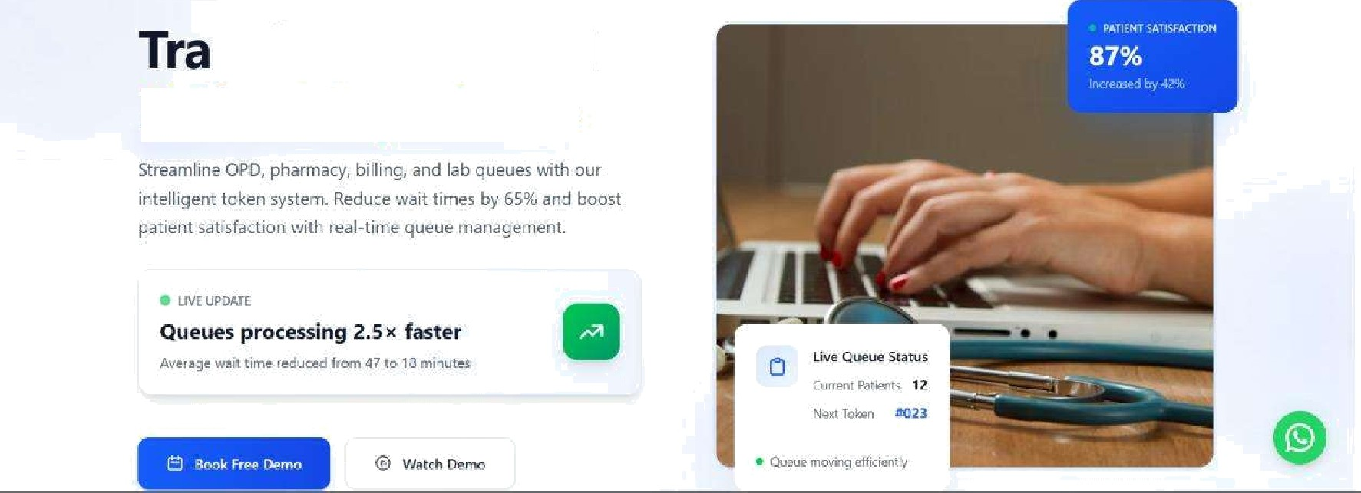
nsform Hospital Patient Experience

- Robato Smart Queue Management System
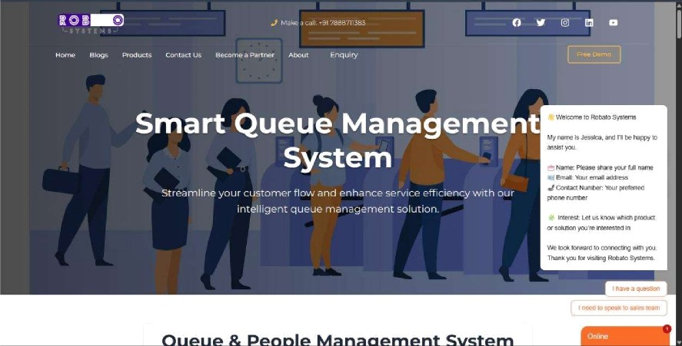

- OueueBee
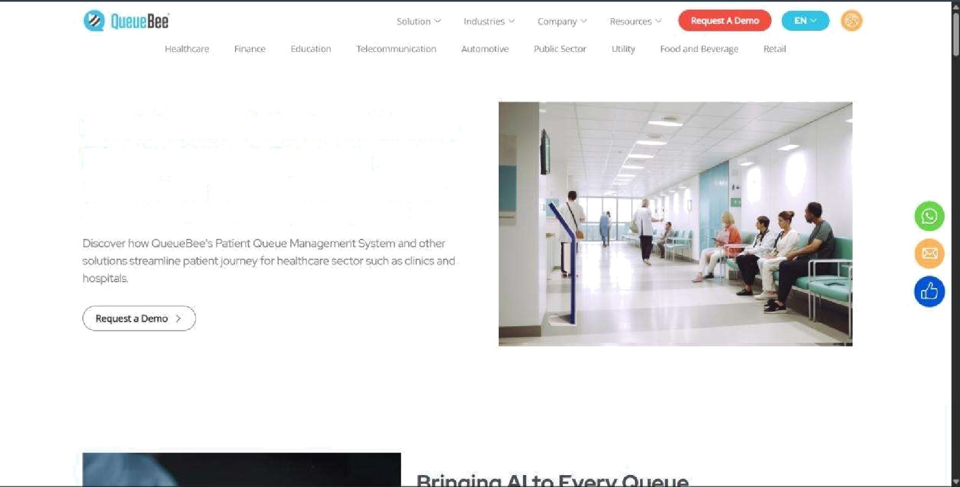

Healthcare & Patient Queue Management System
Revolutionising Patient Experiences Through Al-enabled Queue journey Management

- CBSL Queue Management System
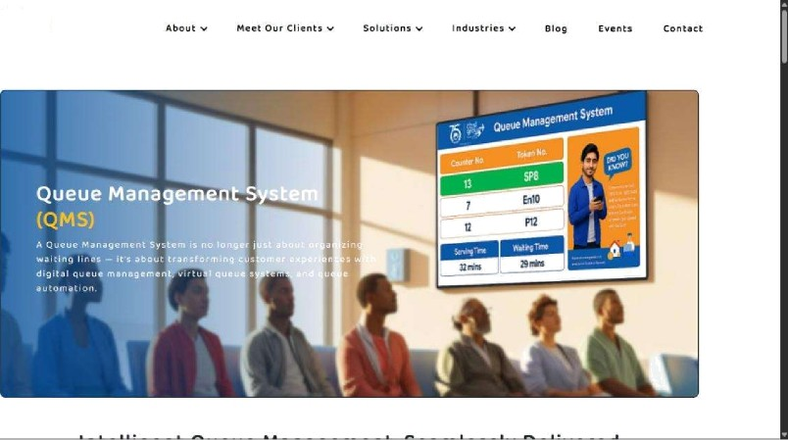


Mobile Applications
- QLess

GxgéPay ow› e e •=

§Less - 9ueuing Software



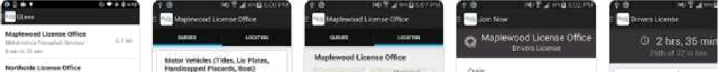



- QueueBee Mobile

G n . . Bo of s !s

QueueBee

. ..I





GLwEeSS

RateO'or3+

App support






Rated for 3+



- whizzQ
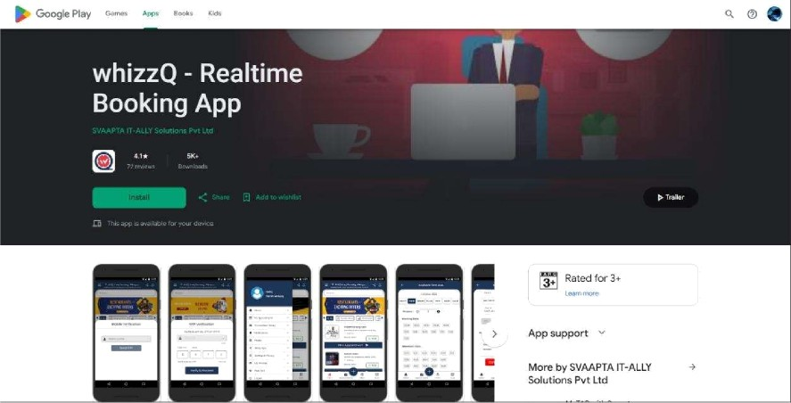

- QueSync



QueSync - Queue Management





6 App support



Aoout this aop

Common Features in Existing Systems
Feature

- User Registration/Login

- Appointment Booking

- Digital Token Generation

- Queue Status Tracking

- SMS/Push Notifications

- Queue Display Dashboard

- Admin Management

- Basic Analytics

- Queue Cancellation/Rescheduling

- Prediction Dashboard

Limitations of Existing Systems
Few systems use sensors for automatic crowd
monitoring.
n designed for only hospitals or only banks.
Cannot predict future workload effectively.
Sudden delays can make estimates inaccurate.
Queues are generally first-come-first-served.
Users must manually choose available slots.
ost systems est1mate wait times using simple
Iculations.
Description
7. Minimal IoT Integration
6. Lack of Multi-Domain Support
5. Limited Resource Forecasting
4. Poor Adaptation to Real-Time
Changes
3. Limited Queue Optimization
2. No Smart Slot Recommendation
1. No Accurate AI Prediction
Limitation

Proposed System

Al-Based Smart Queue Prediction and Intelligent Reservation System

(IntelliQ)
The proposed system enhances traditional queue management by using Artificial Intelligence, Machine Learning, and Real-Time Analytics to predict waiting times and recommend optimal reservation slots.
Unique Features of IntelliQ

Feature  - Appointment Booking  - Digital Token System  - Real-Time Queue Tracking  - Notifications  - AI Waiting Time Prediction  - Smart Slot Recommendation  - Peak Hour Forecasfing  - Dynamic Queue Optimization  - Resource Utilization Prediction | Existing Systems | IntelliQ
 | Yes | Yes
 | Yes | Yes
 | Yes | Yes
 | Yes | Yes
 | No | Yes
 | No | Yes
 | No | Yes
 | No | Yes
 | No | Yes
10. Multi-Sector Support | Limited | Yes

Feature  - IoT-Based Crowd Monitoring (Optional)  - Gesture-Controlled Kiosk (Optional) | Existing Systems  Rare  No | IntelliQ  Yes  Yes
13. Predictive Analytics  Dashboard | Limited | Yes

Comparative Analysis
High
High
5. Automation Level
Medium
High
6. User Experience
Good
Enhanced
7. Operational
Efficiency
Moderate
High
8. Scalability
Limited
Low
4. Adaptability
Smart Recommendation
Static
3. Reservation System
AI-Based Prediction
Approximate
2. Waiting Time
Estimation
Intelligent
Basic
1. Queue
Management
lnteIIiQ
Existing Systems
Criteria

SRS Report of IntelliQ

Table of Contents
Chapter 1: Introduction
  - Purpose
  - Scope
  - Objectives
  - Technologies Used

Chapter 2: Overall Description
  - Product Perspective
  - Product Functions
  - User Roles
  - Assumptions & Dependencies

Chapter 3: Functional Requirements

Chapter 4: Non-Functional Requirements

Chapter 5: Future Scope (Optional)

Chapter 1: Introduction
  - Purpose
The purpose of this Software Requirements Specification (SRS) is to define the functional and non-functional requirements of the AI-Based Smart Queue Prediction and Intelligent Reservation System (IntelliQ). This document provides a detailed description of the system's objectives, features, architecture, constraints, and user requirements. It serves as a reference for developers, testers, project supervisors, and stakeholders throughout the software development life cycle.
The proposed system aims to modernize conventional queue management by integrating Artificial Intelligence (AI), Machine Learning (ML), cloud computing, and real-time analytics to predict waiting times, recommend optimal appointment slots, and improve operational efficiency across multiple service sectors.

  - Scope
The AI-Based Smart Queue Prediction and Intelligent Reservation System (IntelliQ) is a cloud-based, cross-platform application designed to simplify appointment booking and queue management for both users and service providers.
The system enables users to register, book appointments, receive digital queue tokens, monitor queue status in real time, and receive Al-based waiting time predictions along with smart slot recommendations.
Administrators can efficiently manage services, appointments, counters, and queue operations while accessing analytical reports and predictive dashboards to support better decision-making.
The proposed system is intended for multiple sectors, including:
    - Hospitals and Healthcare Centers
    - Banks and Financial Institutions
    - Government Offices
    - Educational Institutions
    - Public Service Centers
    - Customer Service Organizations
The system is designed to support Android, iOS, Windows, macOS, Linux, and Web platforms using a single Flutter codebase with a centralized cloud-based backend.

Objectives
The primary objectives of the proposed system are:
    - To reduce customer waiting time through intelligent queue management.
    - To provide an online appointment booking and reservation system.
    - To generate digital queue tokens automatically.
    - To provide real-time queue status tracking.
    - To predict waiting times using Artificial Intelligence and Machine Learning techniques.
    - To recommend the most suitable appointment slots based on historical and real-time
queue data.
    - To forecast peak hours and improve resource utilization.
    - To provide administrators with analytical reports and predictive dashboards.
    - To support multiple organizations using a centralized cloud-based platform.
    - To improve customer satisfaction through notifications and intelligent scheduling.
    - To provide a scalable and secure solution that supports future IoT and AI enhancements.

  - Technologies Used

Component Technology

Frontend
Programming Language Backend
Database ORM
AI / Machine Learning Real-Time Communication Authentcafon
Push Notifications API Testing Version Control
Flutter Dart
ASP.NET Core Web API
Azure SQL Database Entity Framework Core
Python, Scikit-learn, Pandas, NumPy SignalR
JWT Authentication
Firebase Cloud Messaging (FCM) Postman
Git & GitHub

IDE
Visual Studio 2026, Visual Studio Code,
Android Studio

Chapter 2: Overall Description
  - Product Perspective
The Al-Based Smart Queue Prediction and Intelligent Reservation System (IntelliQ) is a cloud-based intelligent queue management platform designed to improve traditional appointment and queue handling systems.
The system follows a three-tier client-server architecture, where Flutter applications act as clients, ASP.NET Core Web API serves as the application layer, and Azure SQL Database stores all organizational and user data. AI predicfion services analyze historical and real-time queue data to estimate waiting times and recommend optimal appointment slots.
Future versions may integrate CCTV-based crowd monitoring and IoT devices to improve prediction accuracy and automate crowd analysis.

  - Product Functions
The proposed system provides the following major functions:
- User Registration and Authentication
- Appointment Booking
- Digital Token Generation
- Real-Time Queue Tracking
- Queue Cancellation and Rescheduling
- Push Notifications and Alerts
- AI-Based Waiting Time Prediction
- Smart Slot Recommendation
- Peak Hour Forecasting
- Dynamic Queue Optimization
- Resource Utilization Prediction
- Predictive Analytics Dashboard
- Organization and Service Management
- Multi-Sector Support
- Optional CCTV/IoT Crowd Monitoring
- Optional Gesture-Controlled Kiosk
  - User Roles
The proposed system consists of multiple user roles, each with specific responsibilities and access permissions. Role-Based Access Control (RBAC) is implemented to ensure secure and authorized access to system functionalities.

User (Customer)
The User is the primary consumer of the system who books appointments and tracks queue status.

Responsibilities:
      - Register and log in to the system.
      - View available organizations and services.
      - Book appointments by selecting preferred date and time.

      - Receive digital queue tokens.
      - View real-time queue status and estimated waiting time.
      - Receive Al-based slot recommendations.
      - Cancel or reschedule appointments.
      - Receive push notifications and reminders.
      - View appointment history and profile information.

Counter Staff/ Operator
Counter Staff are responsible for serving customers and managing the queue at their assigned service counter.

Responsibilities:
      - Log in to the system.
      - View assigned service counter.
      - Call the next customer in the queue.
      - Mark services as completed.
      - Skip absent customers.
      - Pause or resume queue operations when required.
      - Update service completion status.

    - Super Admin
The Super Admin has complete control over the entire platform and manages all registered organizations.

Responsibilities:
      - Add, update, or remove organizations.
      - Approve organization registrations.
      - Create and manage organization staff counter accounts.
      - Monitor system-wide analytics and reports.
      - Configure AI prediction settings.
      - Monitor database and cloud services.

      - Manage user roles and permissions.
      - Maintain overall system configuration.

  - Assumptions & Dependencies

Assumptions
The proposed system is developed based on the following assumptions:
- Users have access to smartphones, computers, or web browsers with an internet connection.
- Organizations maintain accurate service schedules and queue information.
- Cloud services remain available throughout system operation.
- Historical queue data is available or will be generated for AI model training.
- Users provide valid registration information.
- Service providers regularly update appointment availability.

Dependencies
The successful operation of the system depends on the following components:
- Stable internet connectivity.
- Cloud-hosted database (Azure SQL Database).
- ASP.NET Core Web API server.
- Flutter-supported platforms.
- AI prediction module developed using Python.
- Push notification service (Firebase Cloud Messaging).
- Optional CCTV or IoT devices for crowd monitoring.

